Syuria Amirrudin

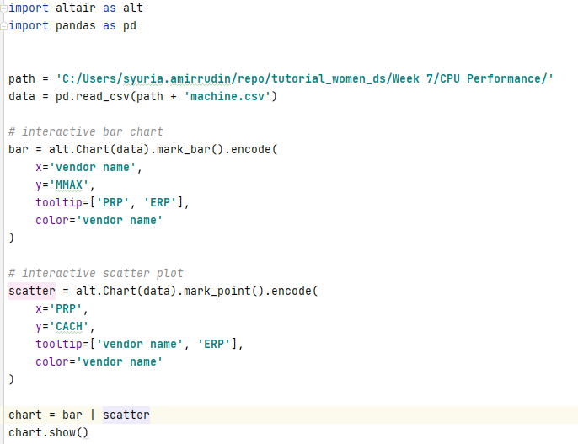

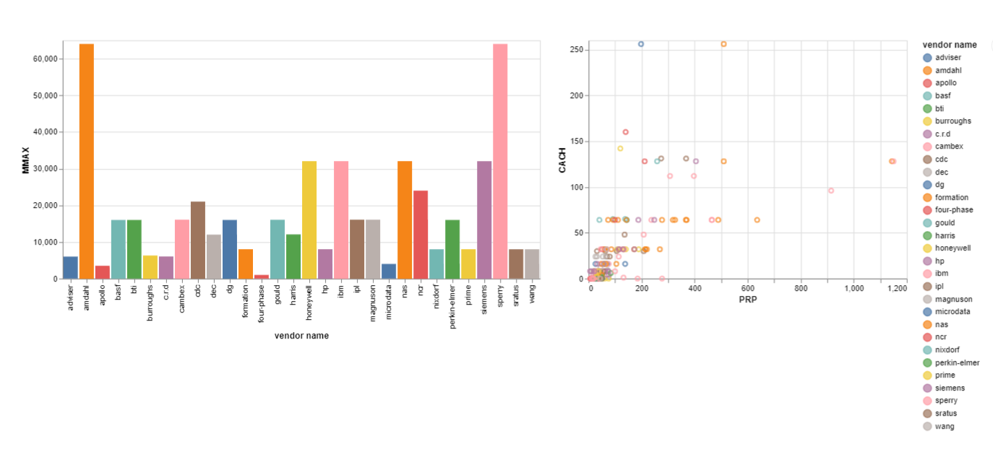

I am using computer performance dataset from https://archive.ics.uci.edu/ml/datasets/Computer+Hardware

There are two charts, bar chart and scatter plot.

The bar chart shows the maximum main memory in kilobytes for each vendor name. If we are looking for a computer with highest main memory, we can decide straight away from this bar chart as we can see 2 vendors that can provide computer with highest main memory.

The scatter plot is to see the relationship between cach memory in kilobytes (CACH) and the published relative performance (PRP). Most computer with cach less than 100 kilobytes have published relative performance less than 400. The mark point help us to directly spot the data point of the interest.